**EMPLOYEE NAME:** [Muthuraj Periyasamy](mailto:muthuraj.periyasamy@relevantz.com)

**Employee Id:11949**

**MICRO PROJECT: Online Courier Services:**

**1.RESISTER:**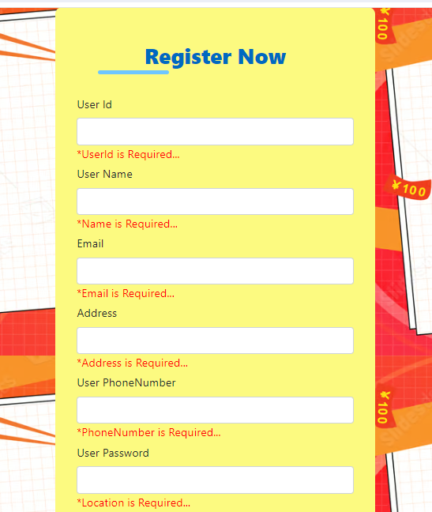

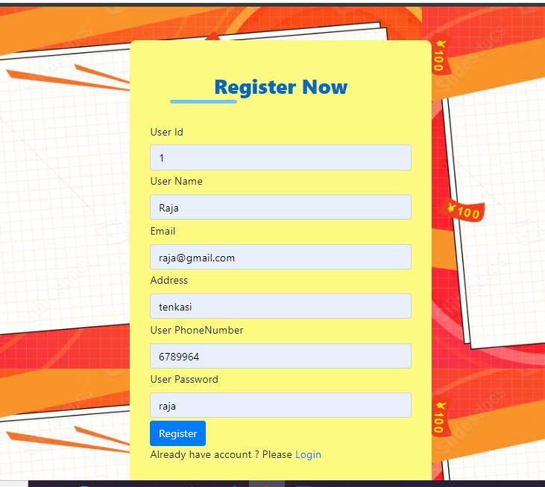

**ENCRYPTED PASSWORD: THIS SECURE PURPOSE:**

**Register:**

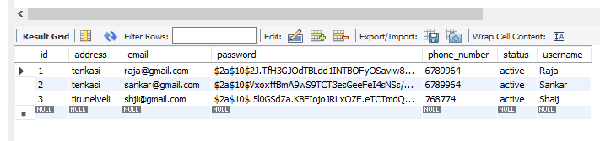

**LOGIN:**

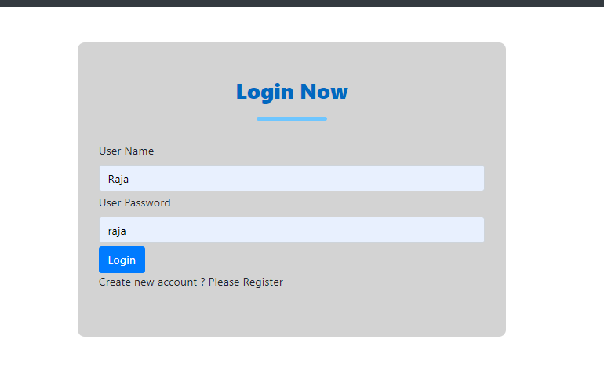

**User: Online Courier Using:**

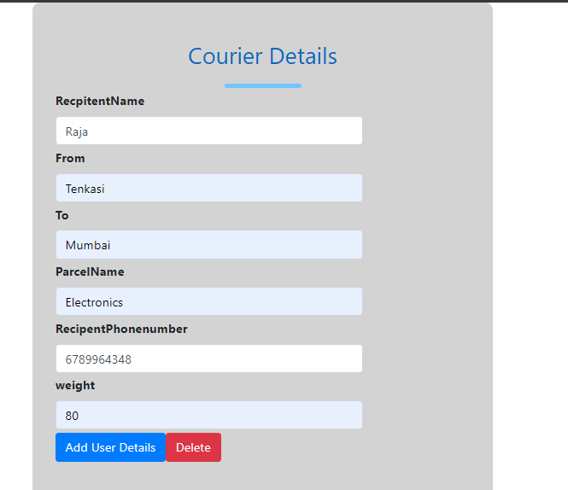

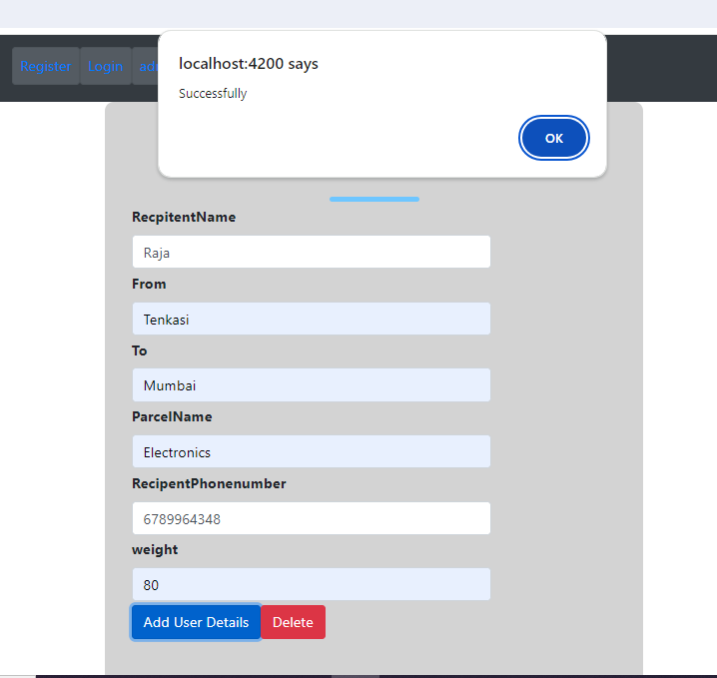

**ADMIN SIDE:**

**1.Admin side coming user courier data:**

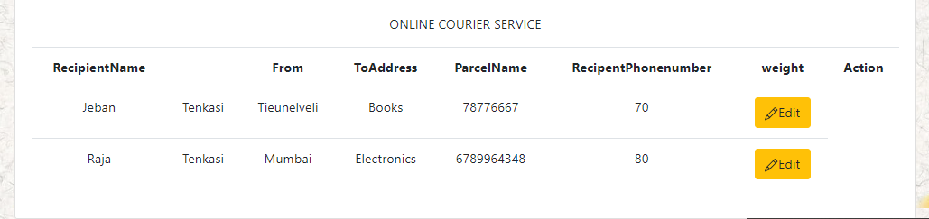

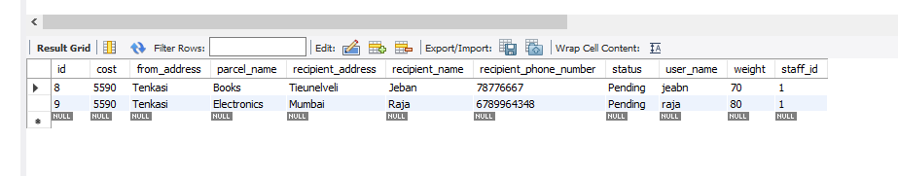

**2.Admin then assign Staff .Because delivery the Courier:**

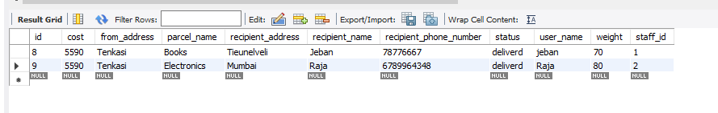

The Successfully Courier delivered:

**ADMIN DELETE :**

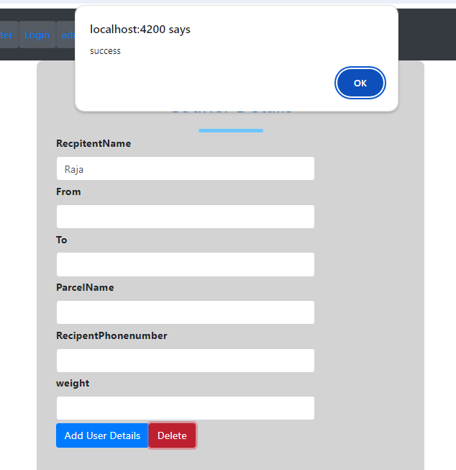

**Successfully Delete Courier Details:**

**Staff:**

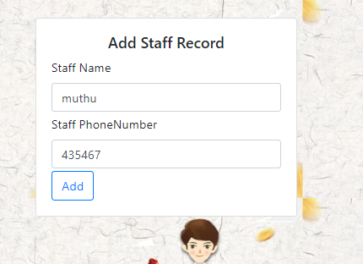

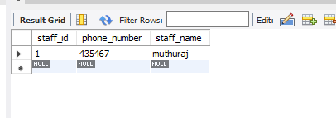

**Delete Staff details:**

